# Lab-4 University Database

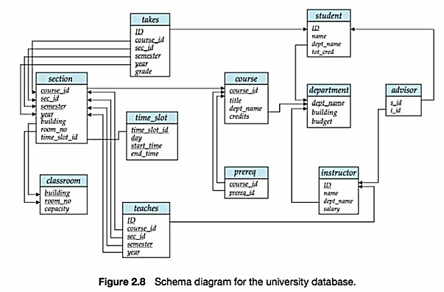

Source: Database Systems Concepts, ISBN9780073523323

Answer the following questions based on the schema diagram provided:

1. Can an instructor work for more than one department? Explain why or why not.

No, as the instructor belongs to a department (through dept_name) and that is a primary key of department. This means an instructor can belong to one department only.

1. Can there be more than one section of a course in a given semester? Explain why or why not.

Yes, as both sec_id and semester are primary keys, so in the same semester, there can be multiple sections of the same course.

1. Can a student have more than one instructor as an advisor? Explain why or why not.

No, since s_id is a primary key in this case, only one student can have one advisor only.

1. Can a course have more than one prereq? Explain why or why not.

Yes, as the course_id and prereq_id are both primary keys, so for one course_id, there can be multiple prerequisites.

Write SQL queries to accomplish the following:

1. List the names of all instructors, along with the name of the department for which they work.

SELECT name, dept_name

FROM INSTRUCTOR;

1. List the department names of all instructors. Eliminate duplicates.

SELECT DISTINCT dept_name

FROM INSTRUCTOR;

1. List the names of all instructors, along with the name of the department for which they work, and the building in which the department is located, sorted by instructor name.

SELECT I.name, I.dept_name, D.building

FROM INSTRUCTOR AS I INNER JOIN DEPARTMENT AS D ON I.dept_name=D.dept_name

ORDER BY name;

1. List the IDs, names, departments, salaries of all instructors, along with the course ID, section ID, semester and year of all courses taught by each instructor.

SELECT I.id, I.name, I.dept_name, I.salary, T.course_id, T.section_id, T.semester, T.year

FROM INSTRUCTOR AS I INNER JOIN TEACHES AS T ON I.ID=T.ID;

1. List all instructor names and their department names who earn a salary in the range of 90000 to 100000 inclusive.

SELECT name, dept_name

FROM INSTRUCTOR

WHERE salary>=90000 AND salary<=100000;

1. List the course ID, course title, and semester for all courses taught in the Fall of 2009 or in the Spring of 2010.

SELECT C.course_id, C.title, S.semester

FROM COURSE AS C INNER JOIN SECTION AS S ON C.course_id = S.course_id

WHERE (SEMESTER=’FALL’ AND YEAR=’2009’) OR (SEMESTER=’SPRING’ AND YEAR=’2010’);

1. List the course ID, course title, and semester for all courses taught in both the Fall of 2009 and in the Spring of 2010.

SELECT C.course_id, C.title, S.semester

FROM COURSE AS C INNER JOIN SECTION AS S ON C.course_id = S.course_id

WHERE (SEMESTER=’FALL’ AND YEAR=’2009’) AND (SEMESTER=’SPRING’ AND YEAR=’2010’);